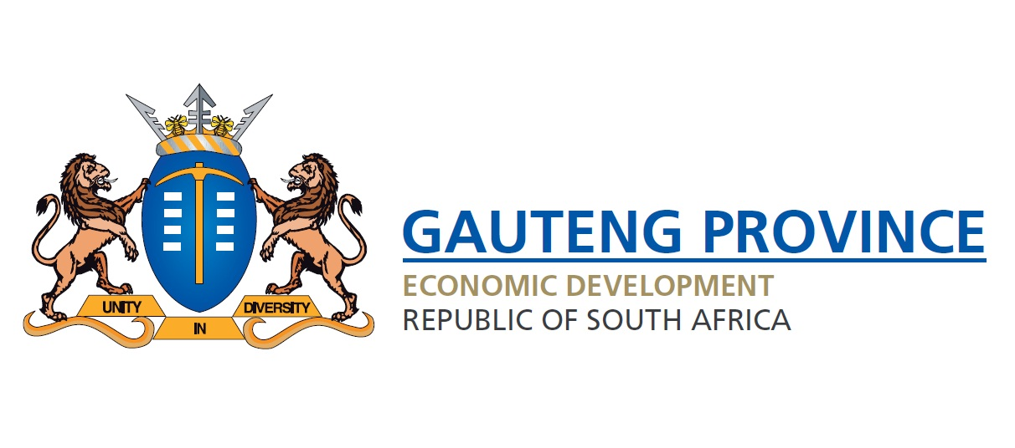

THE REBASING OF NIGERIA ECONOMY-WHAT DOES IT MEAN FOR SOUTH AFRICA AND GAUTENG

“If Nigeria settles down and become orderly and everything is exactly as expected and everyone is on time and so on, I think the fundamental aspects of the Nigerian character will be lost. There are nations that thrive on certain just-about-kind-of-controlled chaos and I think I’m coming to accept that’s how we are” Nigeria Novelist Ben Okri
1. INTRODUCTIONS AND BACKGROUND
Ben Okri observation around the Nigeria “way of life” is something that any visitor who has been to Lagos can testify, but is essence the new high Gross Domestic Price figure gives testimony that the country will grow despite its chaotic “way of life”.
On 07 April 2014, the Nigerian government announces the result of the long-awaited GDP rebasing process. The World Bank and IMF endorsed the process. Rebasing is carried out so that a nation's GDP statistics give the most up-to-date picture of an economy as possible. Most countries do it at least every three years or so, but Nigeria had not updated the components in its GDP base year since 1990 whereas Africa’s base year is 2010.
To further press home the necessity of the rebasing exercise, the structure of Nigeria’s economy has changed a lot since 1990. Then, the country had one telecoms operator with around 300,000 phone lines. Now it has a whole mobile phone industry with tens of millions of subscribers. Likewise, 24 years ago there was only one airline, and now there are many.
Rebasing does not change what was already there; it’s just about measuring better and more accurately. It does not mean that within 24 hours something miraculous has happened because if it has, Nigeria will have seen the return of its citizens and entrepreneurs from every corner of the World including South Africa. Many Nigerians, who ply their trade in South Africa believe that this is a statistical exercise to correct the anomaly in the measurement of their economy and that its does not change anybody’s fortune as the poverty level, infrastructure gap and so forth is as it was before the rebasing outcome.

The previous base year of 1990 has become outdated due to changes in the structure of the economy. The National Bureau of Statistics (NBS) recalculated the value of GDP based on production patterns in 2010, increasing the number of industries it measures to 46 from 33 and giving greater weighting to sectors such as telecommunications and financial services.

On paper, the size of the economy expanded by more than three-quarters to an estimated 80 trillion naira (US $510 billion) for 2013. That compares with the World Bank’s 2012 GDP figures of US $262.6 billion for Nigeria and $384.3 billion for South Africa.

The increase in sectoral contribution to GDP provided better coverage for the new industries (including the informal sector), and methodological improvements led to significant increases in the contribution of the services sector, manufacturing, construction, and water and electricity. On the other hand, value added by the agricultural and the oil and gas sectors declined notably relative to GDP. These latter sectors were the dominant sector of the economy in 1990.
The agricultural sector contributed 35 per cent to GDP prior to rebasing, but is now only estimated to account for 22 per cent of GDP. Meanwhile, the services sector’s contribution increased from 29 per cent of GDP to 52 per cent of GDP, with the telecommunications sector rising from 0.9 per cent of GDP to 8.7 per cent of GDP.
The manufacturing sector is now estimated to contribute 6.8 per cent to GDP, compared to just 1.9 per cent previously, while the oil and gas sector’s contribution has been revised down to 14.4 per cent from 32.4 per cent before rebasing.

Final rebased GDP figures are scheduled for release by June 2014. The NBS plans to rebase GDP figures every five years to ensure that estimates remain up-to-date.

2. WAS THE REBASING OUTCOME A SURPRISE?
There has always been expectation that Nigeria will have to rebase the economy at some stage. In fact, as far back as 2005, the country did not carry the exercise because it was pursuing the debt relief programme under the highly indebted poor countries (HIPC) scheme. It is obvious that, had the carried the rebasing then, their creditors, including the Paris Club will not have written off their debt as the country will have been classified a low-middle income country on the basis of the current rebasing figures.
They were also held back by unrealistic statistics from the household surveys and the industries they wished to include as it could have led to wrong estimations.
So, the rebasing itself was not a surprise, but the new GDP figures were better that all the experts projections, who have expected the new figures to be 60% more than the 1990 base year figure
3. THE ADVANTAGES OF THE HIGHER GDP IN NIGERIA
As expected, Nigeria’s GDP rebasing has given the country a greater positive outlook in terms of economic size and other indicators like the debt to GDP ratio, and the country’s per capita income. It has also firmed up Nigeria’s position as an emerging market economy and helped improve the country’s economic profile amongst among the investors. Nigeria’s debt-to-GDP ratio has declined to 11 percent from the 20% before rebasing providing the country a borrowing space to fund its infrastructure plans.

The rebasing exercise has almost doubled GDP per capita, placing it among low middle-income countries. However, at just $3,000, per capita income is low – and well below South Africa's at $8,736, but this is because of the country huge population of 170 million compared to South Africa’s 51-plus million people.

4. THE DISADVANTAGES OF THE HIGHER GDP IN NIGERIA
A drawback of the GDP rebasing is that it will further exaggerate Nigeria’s poor human development indicators. With a GDP size that may place Nigeria as an emerging economy, it becomes more tenuous for policy makers to explain the current significant poverty and unemployment levels within the country.
The undesirable consequences is that Nigeria might stop getting aid and grants from Millennium Development Agencies and global donors, because the rebasing will be seen as a strong economy, strong enough to cater for its poor, which in the real sense is not.
While GDP depicts how rich a nation is, this is not necessarily the same as showing how rich the individuals in the nation are, due to the problem of unequal distribution of wealth. Similarly, growth in GDP is not synonymous with job creation. Nigeria also overtakes South Africa, in inequality stake as a result of rebasing. Using the Gini coefficient measure; inequality has risen from 0.40 to 063.
Similarly, rebasing has not changed the extreme poverty ( for those living on less than one dollars per day) level, which has increased with an increased economic growth and enlarged GDP. It is estimated that 61 percent of Nigerians were living on less than a dollar a day in 2010, up from 52 percent in 2004.

5. SOUTH AFRICA’S OFFICIAL VIEW ON NIGERIA’S NEW STATUS
Finance Minister Pravin Gohdran reiterated South Africa’s government position when he indicated that the rebasing outcome “ sets up a climate where the most populous nation on the African continent is beginning to move forward. It also comes at a time when, for the last six or nine months, you had a negative narrative about emerging markets generally.”

This official view reflect that South Africa is not at all threatened by the new Africa powerhouse but it sees it within the Framework of Abuja Treaty of Africa Union that says that for Africa economic integration to be realized, it will have to be anchored by strong regional economies that takes leadership on both economic and politics of their regions. So, Nigeria’s achievement fit that picture very well for the West Africa. And the adulation will be the same if Kenya/Ethiopia was to emerge as an economic powerhouse in East Africa.

South Africa with its strong footprint in Nigeria will surely benefit from the new position in Nigeria. With such a small industry reflected by manufacturing 6.8% contribution to the GDP, Nigeria is a large consumer market that is dependent on imports and South Africa must consolidate its position in the Nigeria market

The implications for South Africa and Gauteng
Nigeria has more than 40-million consumers in the middle-income segment — just shy of South Africa’s total population of 51-million — with millions more expected to join in the next decade. There is also a large swathe of Nigeria’s unbanked population where interested foreign banks, telecoms and retailers are angling to come into the country, like First Rand Bank of South Africa, MTN and Shoprite, because of an increase of purchasing power.
The opportunities are abound for Gauteng to increase the presence of her companies in Nigeria. Officially, it will be important to establish relations through twin city agreement with Nigeria’s commercial capital, Lagos.
The following Gauteng sectors stand to benefit from Nigeria fortunes:
- Automotive-BMW, Ford, Nissan and Renault;
- Pharmaceutical
- Banking sector- other banks to follow First Rand example;
- Telecommunication-MTN has already taken a lead;
- Mining and metal fabrication;
- Retailers-following Shoprite lead;
- Construction and building material given the huge infrastructure deficit in Nigeria; and
- Agro-processing.
The most practical steps to promote South African industries, is for Gauteng Growth and Development Agency to specifically reach out to Nigeria business through partnership with the Nigeria Embassy and Consular.
Joint exhibitions between Gauteng and Nigeria business should be planned in Nigerian cities. It is important to develop intelligence on doing business in Nigeria to reduce negative exposure that befell some of the South African who had an expensive exit from Nigerian market. With more information, Gauteng will indeed benefit from Nigeria’s new status.

